**WasteWise- AI that sorts out waste types**

Project by- Ansh Barat

For IngeniumSTEM Winter Hacks 1.0

**Problem, Solution and impact on social good:**

Include the problem statement, your solution, the impact, and how it addresses the topic of social good.

In my country, many people do not put waste into the correct bins allocated for them. This becomes extremely cumbersome to sort and in the end they are just sent to landfills. I wanted to make something that resolves this issue, hence, I made an AI which uses computer vision to sort out waste types, even telling the user how to dispose of the waste correctly. This could really impact the world in a good way if implemented on a large scale (for example, put the waste in front of a dustbin and the dustbin tells you how to dispose of it etc) . Many ideas have been proposed about a smart dustbin, but all of them seemed too complicated in my view. This is the simplest way one can create the system used in a smart dustbin.

**Opening the project!**

To **Open the project**,from the given link (<https://mblock.makeblock.com/project/3328581> ) click on **source code**. This way you can get the access to the project with codes and teachable training model, and see the code in action

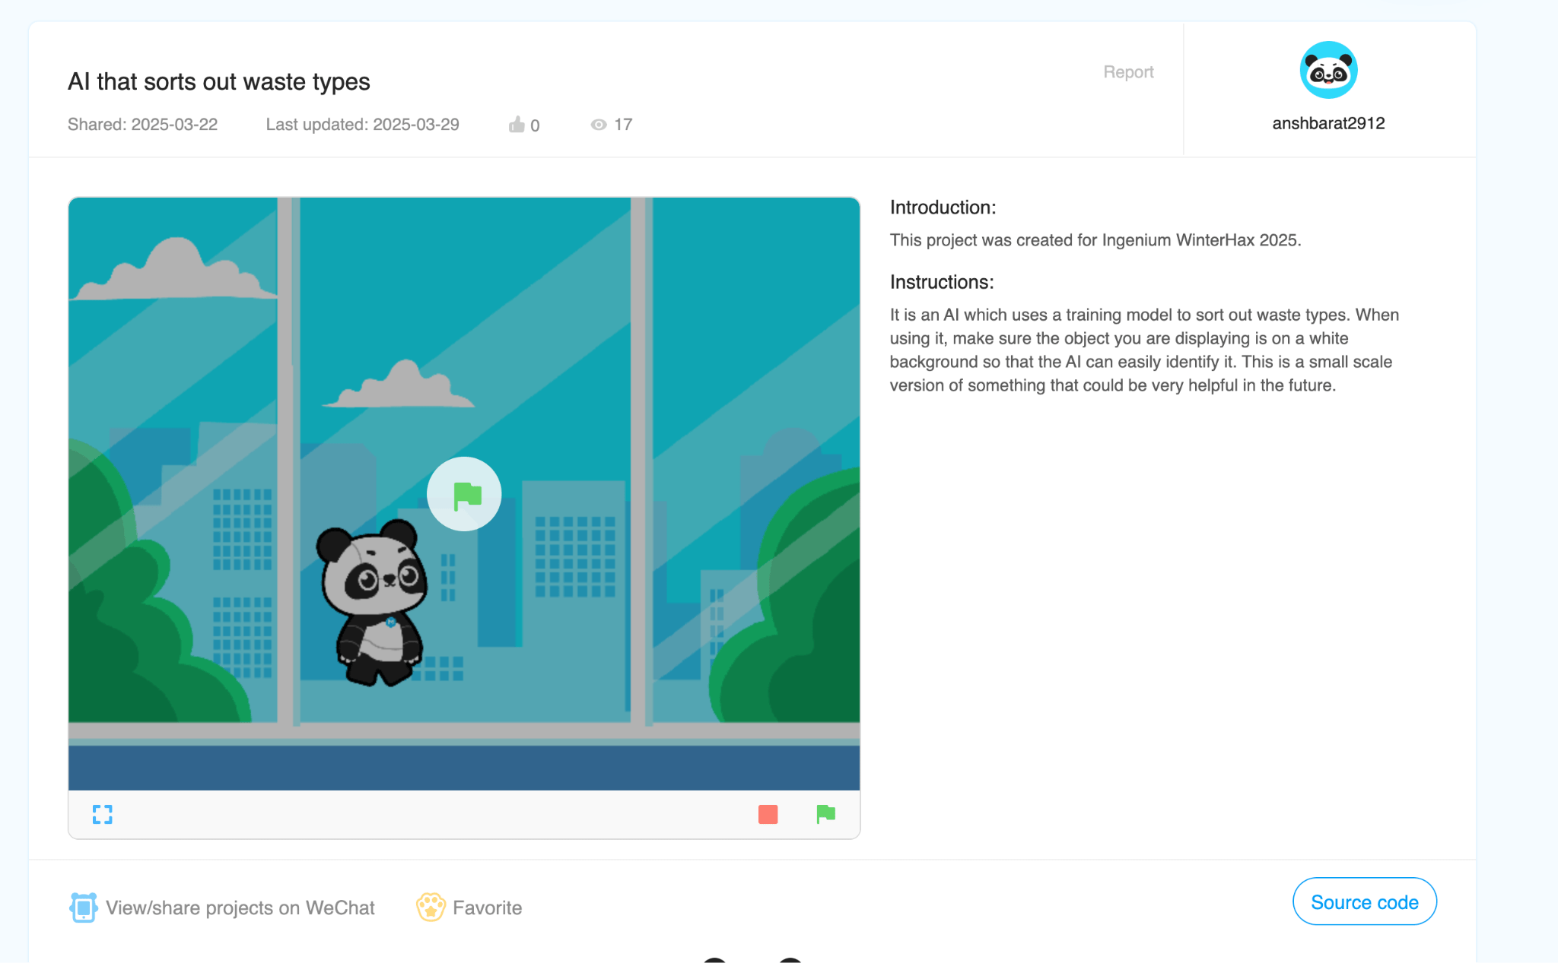

By clicking on the green flag symbol  you can start the project. Just show the object in front of the camera from the waste categories and the AI project will sense, sort and tell you the best disposal methods in seconds!

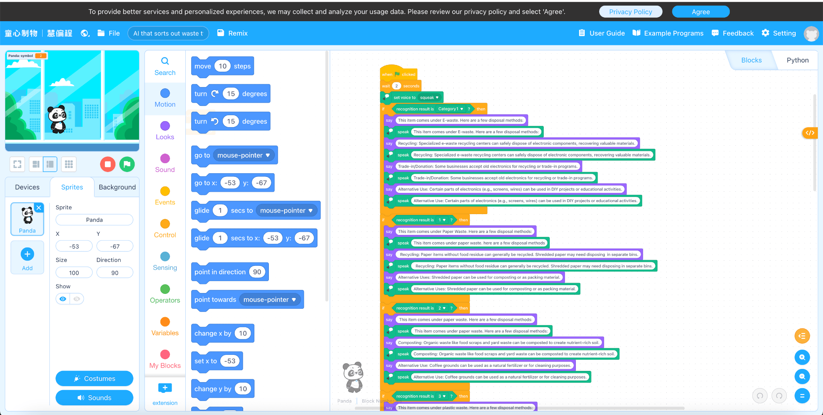

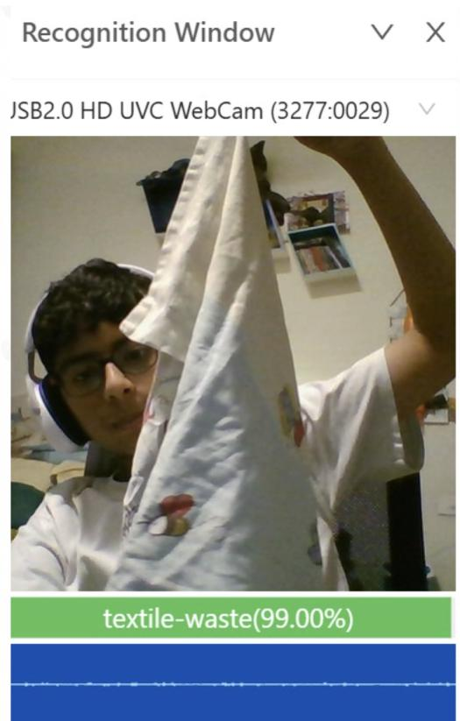

Handkerchief as being recognised as textile waste!

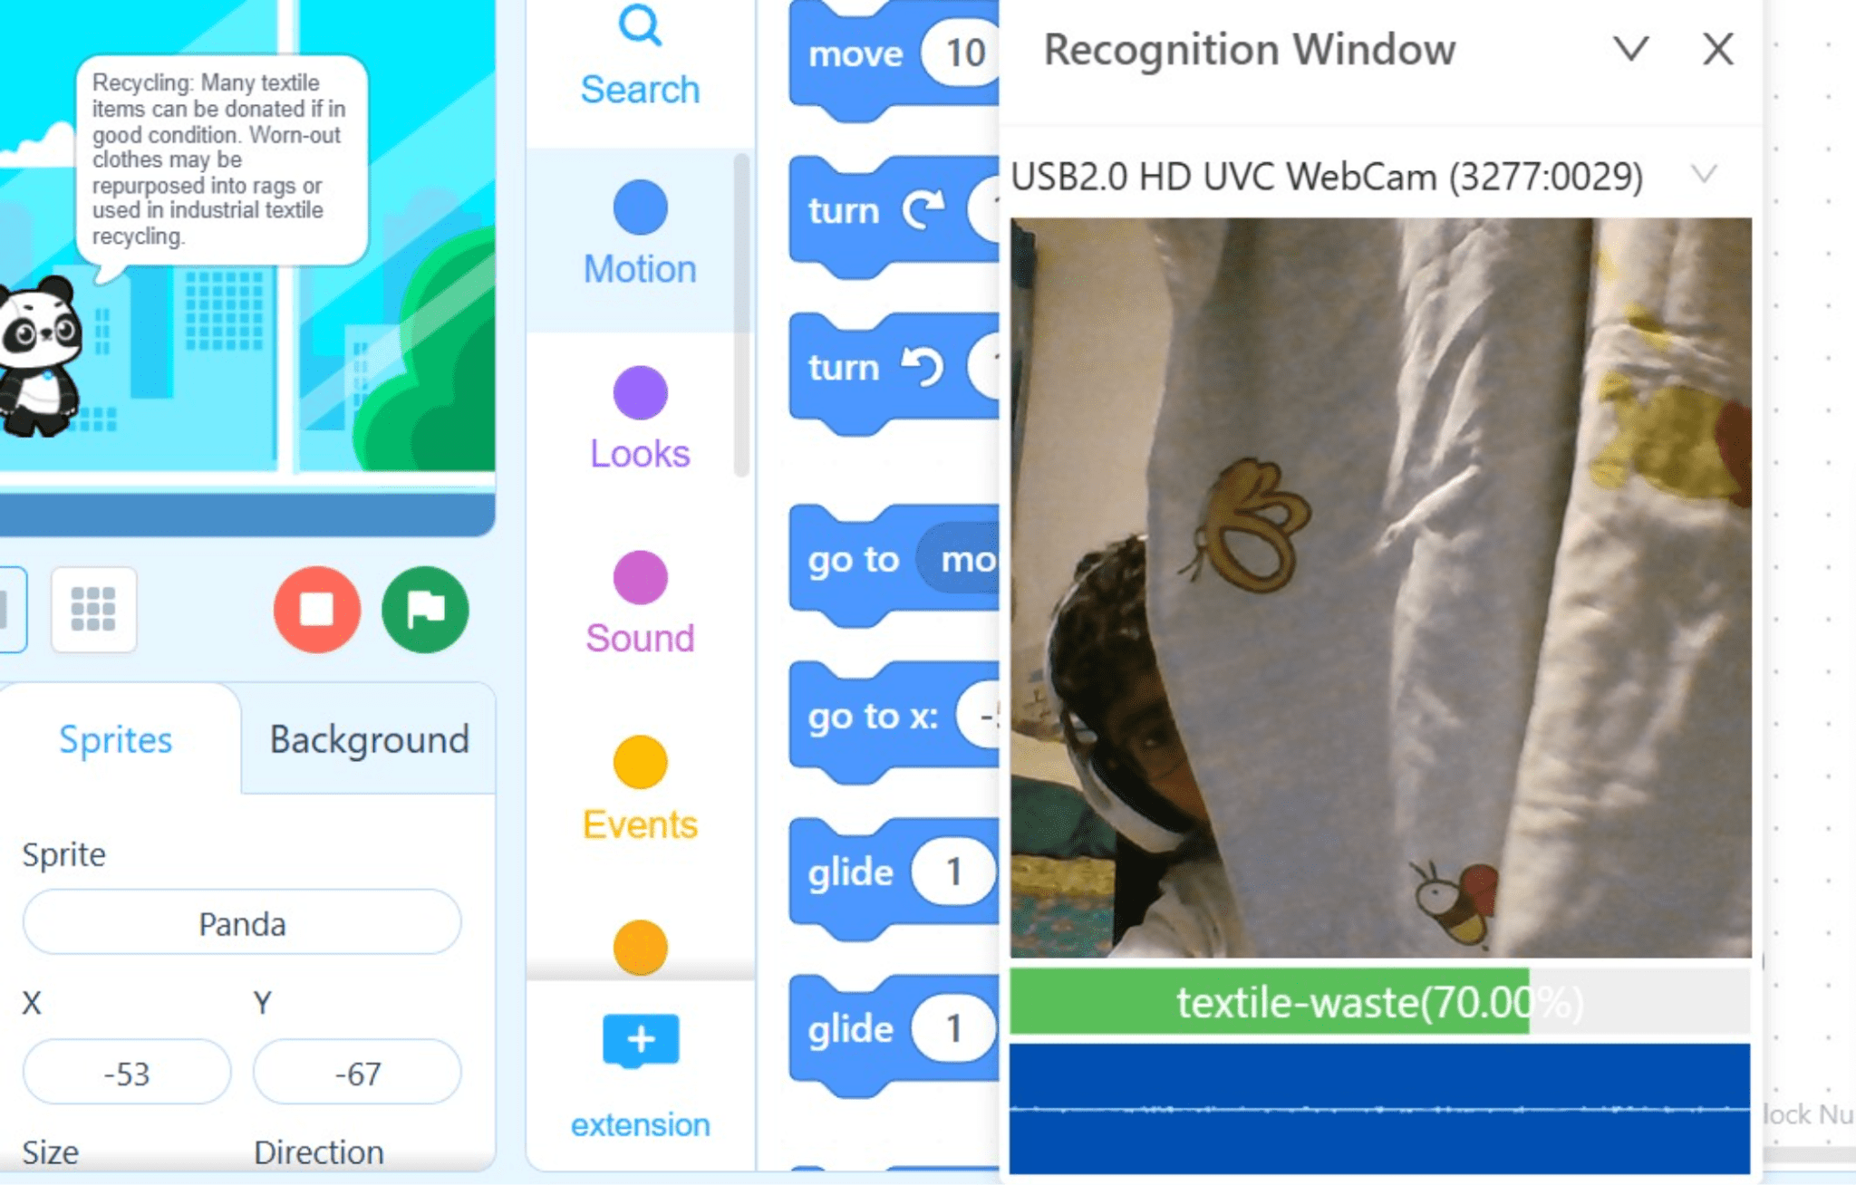

AI waste sorting gives us the best disposal method!

**Logical flow for my project!**

Ideation to Creation!

* Training the model- train it by dividing the wastes into different categories eg. E waste, organic, plastic, food waste etc. When a mobile, pad, laptop, pc etc is shown to the training model, it will classify it as E-waste and using this information, we can further code the sprite to tell us the best disposal method for the shown item.
* Choosing a sprite- any sprite of our choice/appeals to us that will be coded. The task of the sprite will be to be the face of the AI. It can type text to us (chatting) or speak to us (conversing).
* Coding- according to the recognition result obtained from the training model, each category will be assigned the best disposal method which will be displayed next to the sprite and spoke
* Testing phase- Making sure the training model is perfect, the code is recognisable and the project works perfectly.
* Documentation- Documenting each and every step in the Google Doc.
* Video Making- We will be clicking pictures and getting the video of the working model and the ‘HOW’ behind the WOW'

**Research Data**

**Disposal methods for different waste Types.**

**Type 1: E-waste**

Examples:

* Old smartphones, computers, and tablets

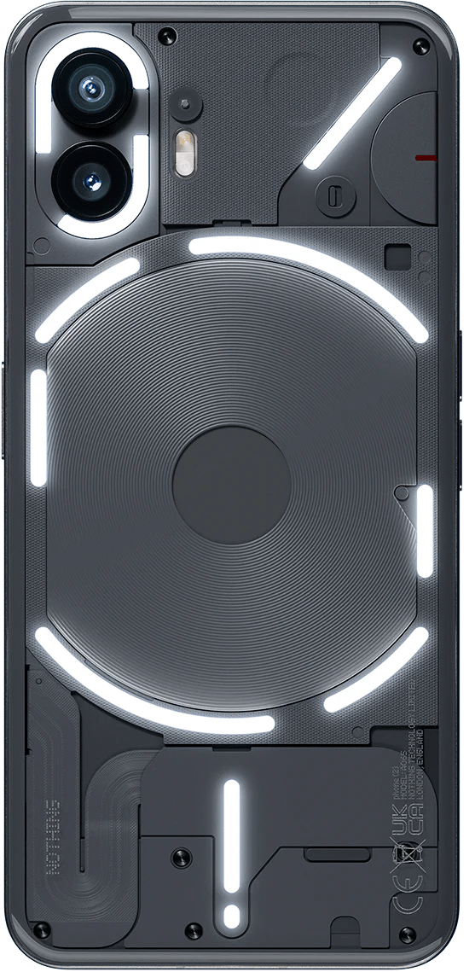

* Broken chargers, cables, and adapters

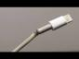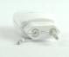

* Batteries (especially rechargeable ones)

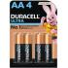

* Light bulbs (energy-efficient CFLs, LEDs)

,]

Recycling: You can do this yourself if you have experience. If not, You can send it to the company’s recycling program or take it to a collection site.

Donating: If the item you want to dispose of is in good and working condition, you can also donate it to someone who is in need of it.

Incineration: This can be done by a machine. It will burn the object and convert it into energy for usage. For example, the heat given out can be used for electricity.

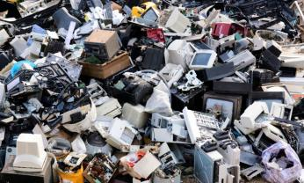

**Type 2: Organic waste**

Examples:

* Fruit and vegetable scraps



* Coffee grounds



* Eggshells



* Yard waste (grass clippings, leaves)



Composting: It is a natural process that breaks down organic waste in the presence of oxygen

Anaerobic Digestion: It is an artificial process that breaks down waste in the absence of oxygen

Recycling: It can help convert the waste into something entirely different such as sustainable products, manures and energy

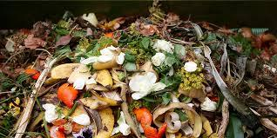

**Type 3: Plastic waste**

Examples:

* Plastic bottles

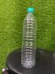

* Food containers (yogurt cups, deli containers)

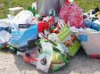

* Plastic bags



* Plastic utensils



* Plastic wrap



Microbial Degradation: It is a reliable process which uses microorganisms to break down plastics easily. It is safe and cheaper than other methods.

Incineration: Common for other wastes, it can be done by a machine. By burning the object and converting it into sources of energy.

Landfilling: Often a last resort, It is used to pile up objects in an area to dispose of them away later.

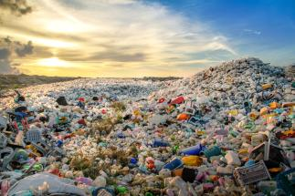

**Type 4: Paper waste**

Examples:

* Newspaper



* Magazines



* Office paper



* Paper packaging (cereal boxes, etc.)

**Disposal Methods:**

* **Recycling:** Paper items (excluding those with food residue) can generally be recycled. Shredded paper may need to be disposed of separately in specialized bins.
* **Alternative Uses:** Shredded paper can be used for composting or as packing material.

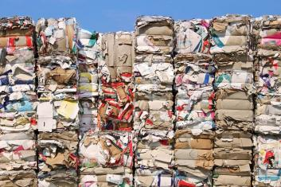

Similarly all the other categories were decided and researched upon.

**Phase 1: Choosing a sprite!**

Any sprite of our choice/appeals to us that will be coded. The task of the sprite will be to be the face of the AI. It can type text to us (chatting) or speak to us (conversing).

Attach appropriate screenshots and explain the process briefly. This should be done for adding extensions and using TM model codes. Explain which extension does what.

The chosen sprite comes with a set of codable blocks. Select the background for the panda of your choice.

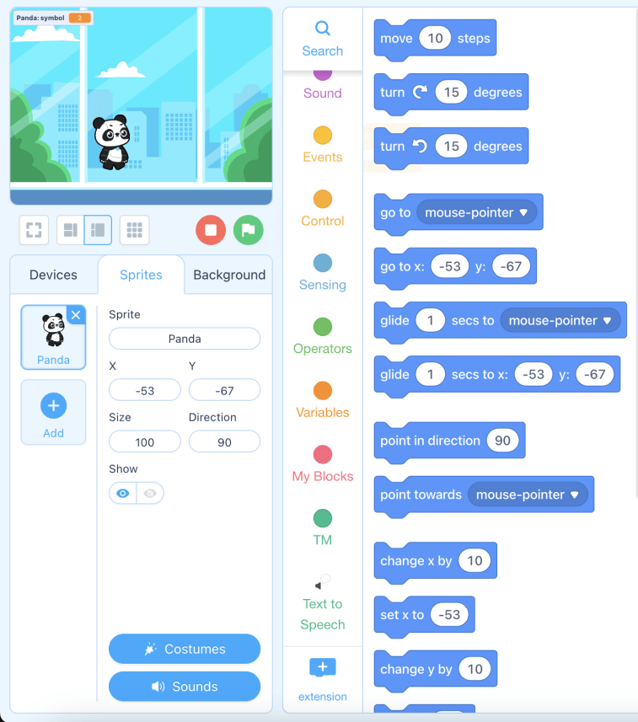

You can use the + extension block to add more blocks.

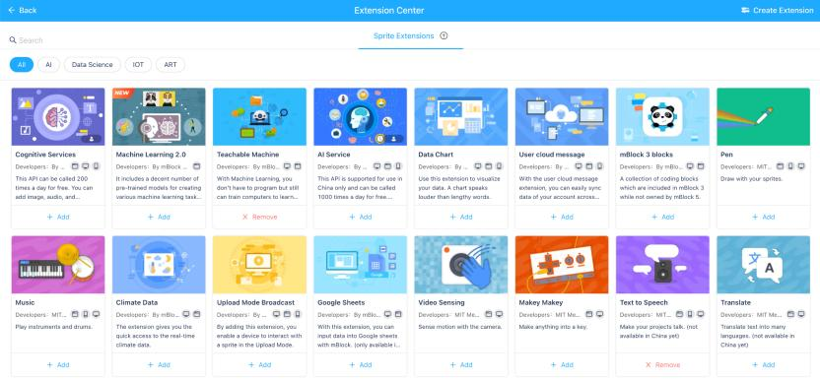

In the extension centre, we can choose from the many given extensions, but for this project “Teachable Machine” and “Text to speech” will be needed.

**Phase 2: Training the model!**

*Train it by dividing the wastes into different categories eg. E waste, organic, plastic, food waste etc. When a mobile, pad, laptop, pc etc is shown to the training model, it will classify it as E-waste and using this information, we can further code the sprite to tell us the best disposal method for the shown item.*

Attach appropriate screenshots and explain the process briefly. This should be done for the training and testing phase of the model. See below for reference:

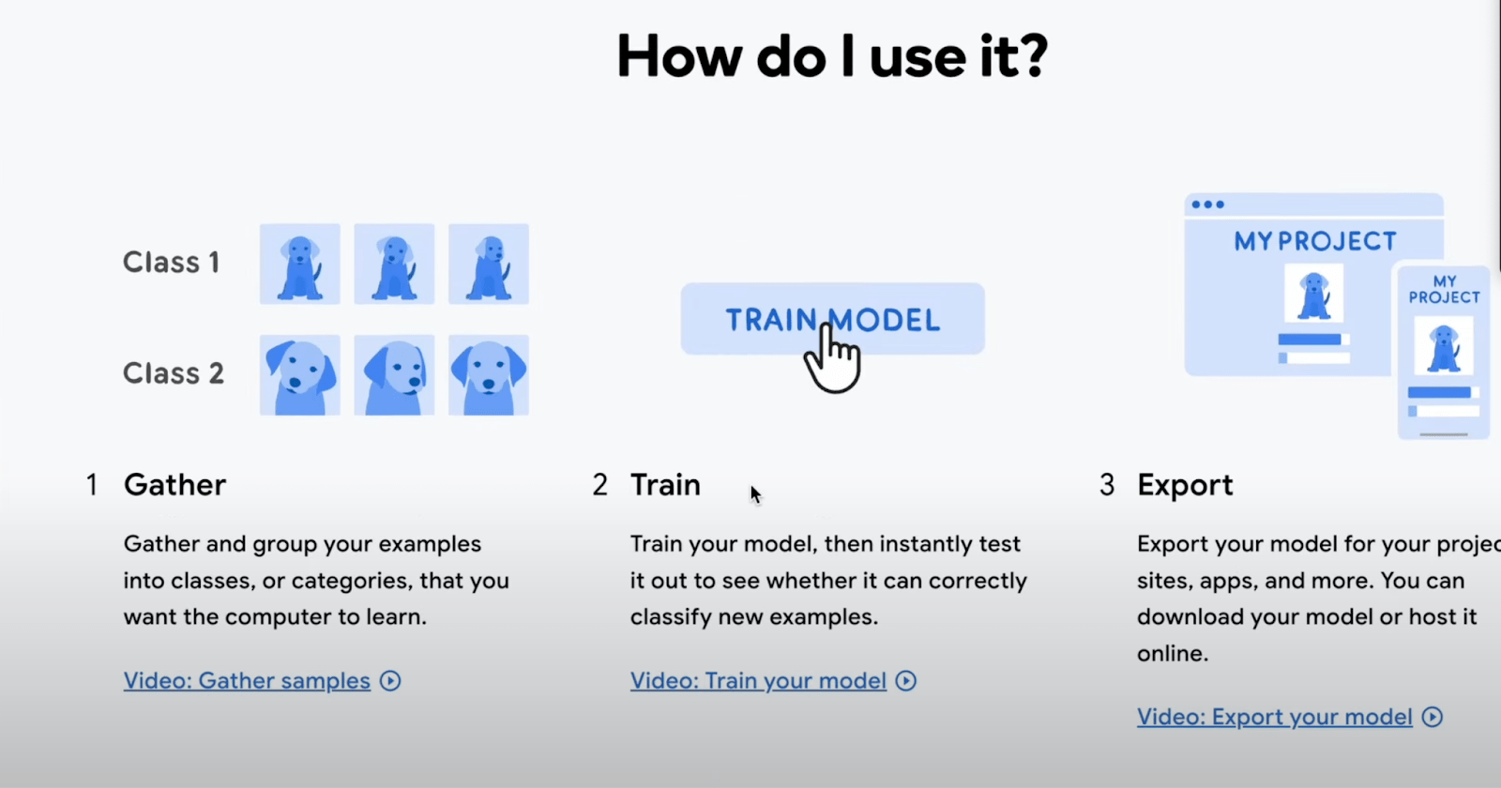

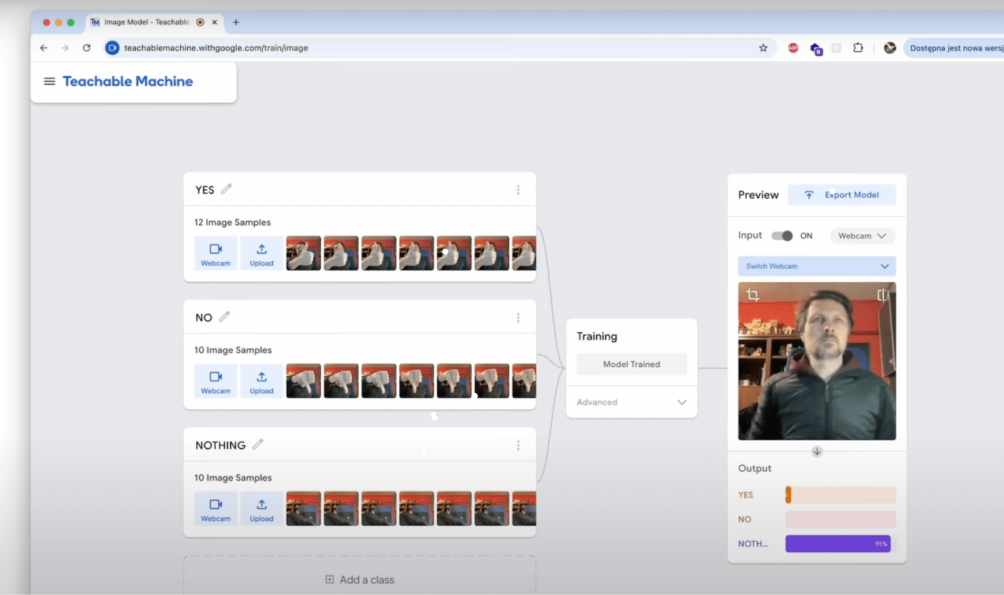

Open teachable machine extension, Train a model by adding different categories, like E waste, paper waste.

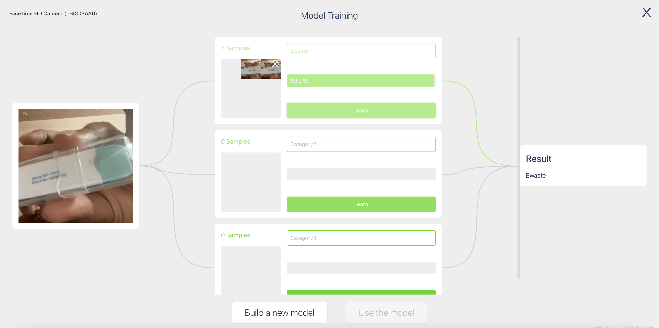

Similarly add all the categories, add all the relevant data images to train the model for all the categories of waste and use the model.

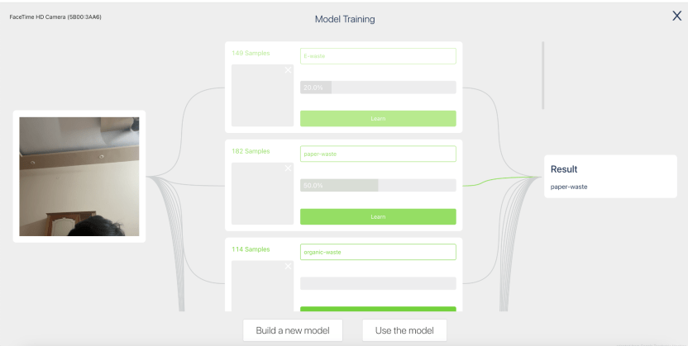

**Phase 3: Coding!**

Explain the logic of the code: according to the recognition result obtained from the training model, each category will be assigned the best disposal method which will be displayed next to the sprite and spoke

Attach appropriate screenshots and explain the entire coding process briefly. This should be done for all the codes you have and using different colored code blocks explaining their needs and their use. Explain which block does what.

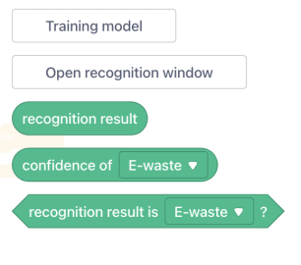

In the teachable machine extension blocks these three blocks give us the result of the model. Whatever is shown in the camera, will be detected and used as the recognition result.

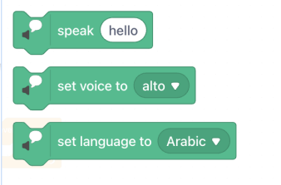

In the text to speech extension blocks these three blocks give us the freedom to convert text to voice messages, this is how our sprite will guide the users for the best disposal method.

Let’s see the detailed code for the project that does the magic of bringing AI waste sorting to life!

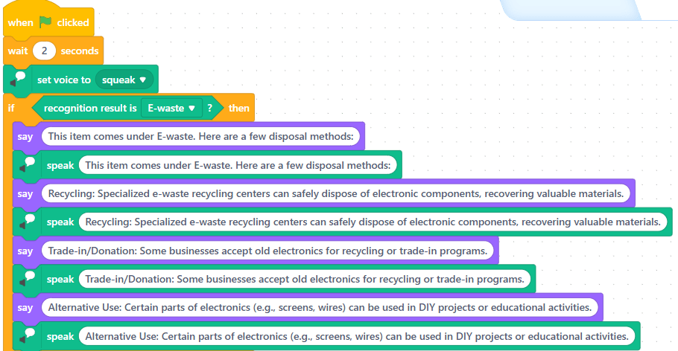

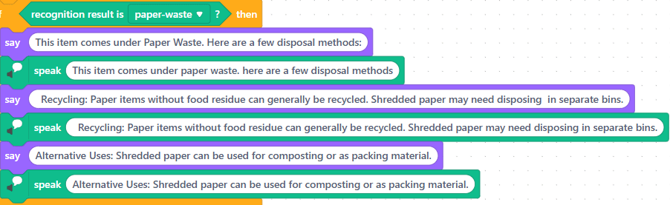

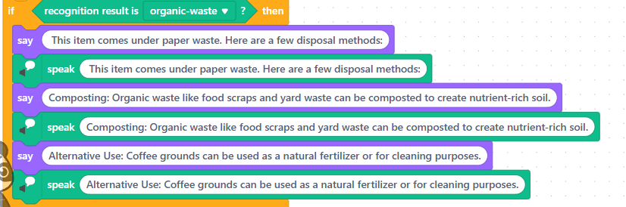

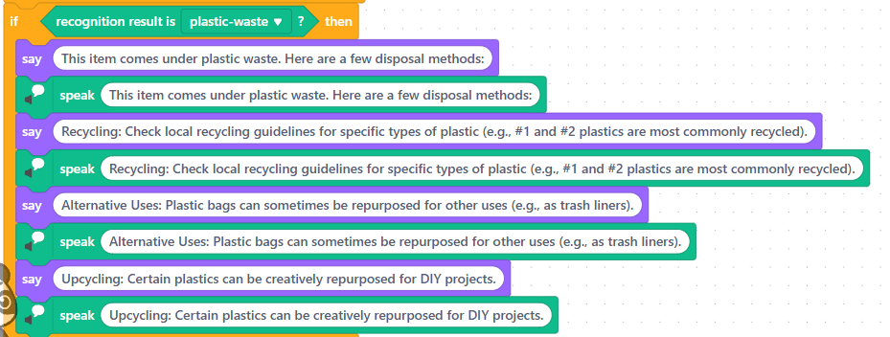

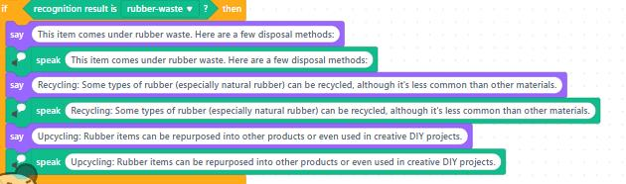

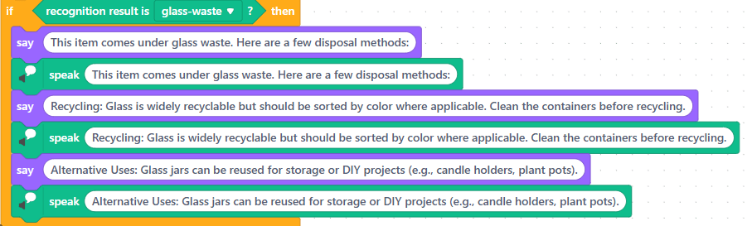

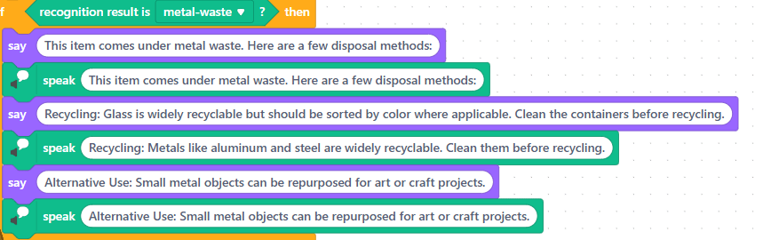

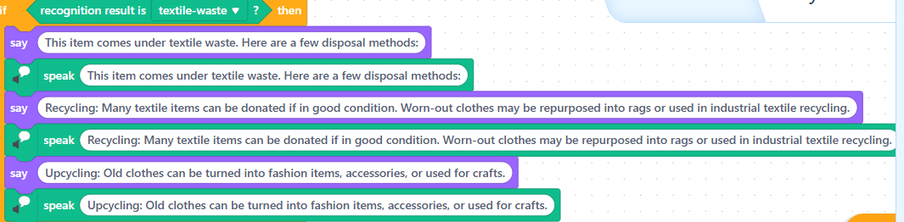

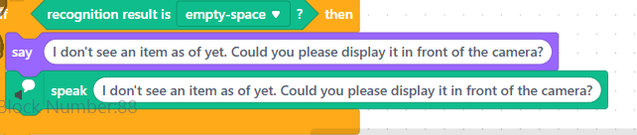

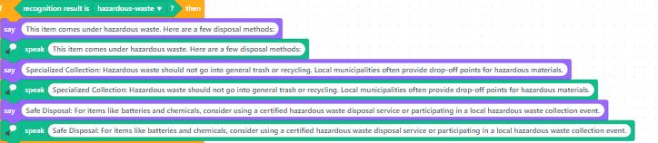

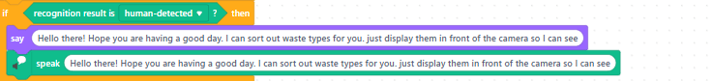

The green flag is the symbol to click when you want the code to start. The ‘wait 2 seconds’ is for you to show the object properly. The set voice block has multiple voice presets, so I chose the one that sounds most like a panda (which is the sprite for this project). Then, the if blocks are used for the condition where a specific waste type is shown. “If” laptop is shown, which comes under e-waste, then the training model will allocate the image as e-waste and the sprite will give the disposal method for that category. The recognition result block shows which result is recognised by the AI from the training model or teachable machine. The ‘say’ block is the one that helps display the text which is written in the white space on the screen and the ‘speak’ block uses the voice set earlier to say what is typed in the white space.

**Phase 4: Testing phase!**

Making sure the training model is perfect, the code is recognisable and the project works perfectly.

Attach appropriate screenshots and the working video unlisted youtube link. This should be for the training and testing phase of the model. See below for reference (attached in the videos):



Handkerchief as being recognised as textile waste!



AI waste sorting gives us the best disposal method!

Here is the Link to the youtube video that shows my project in action!

<https://youtube.com/shorts/P0Q_28KjHlo?si=n2EIoKrytkJS9Sjb>